Information Technology Solutions

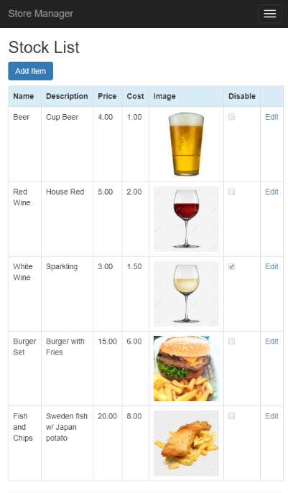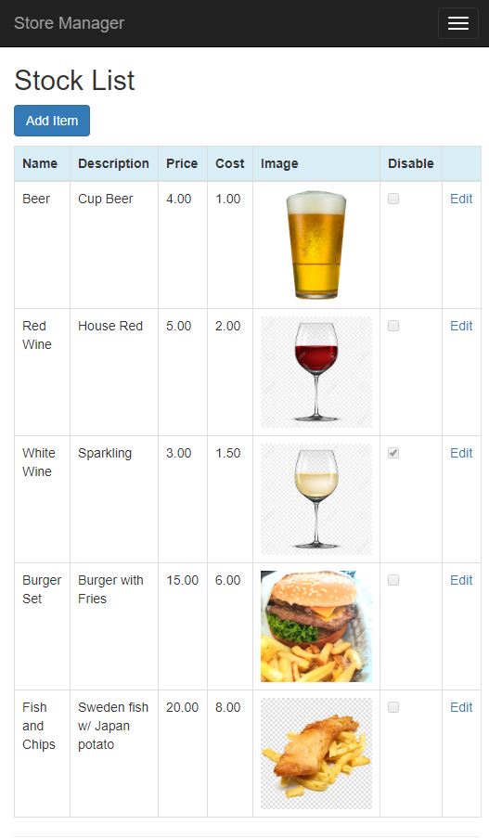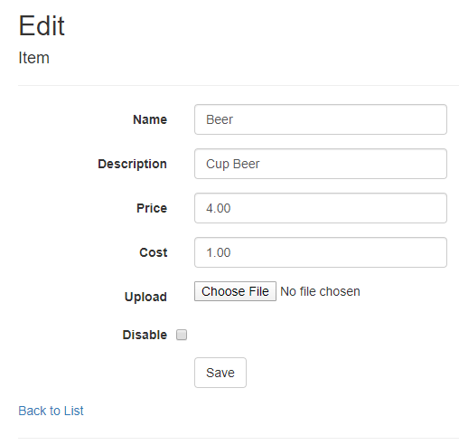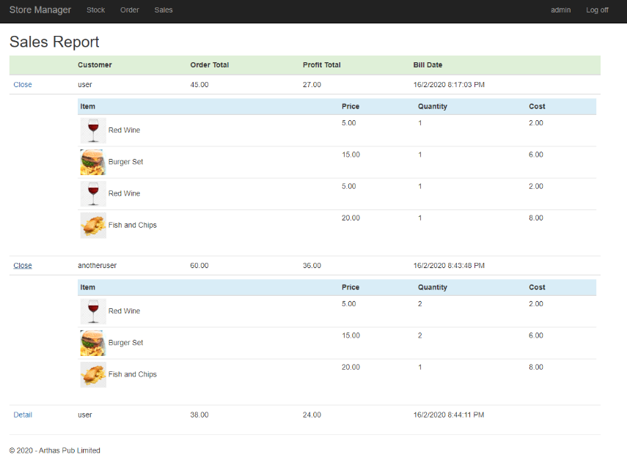 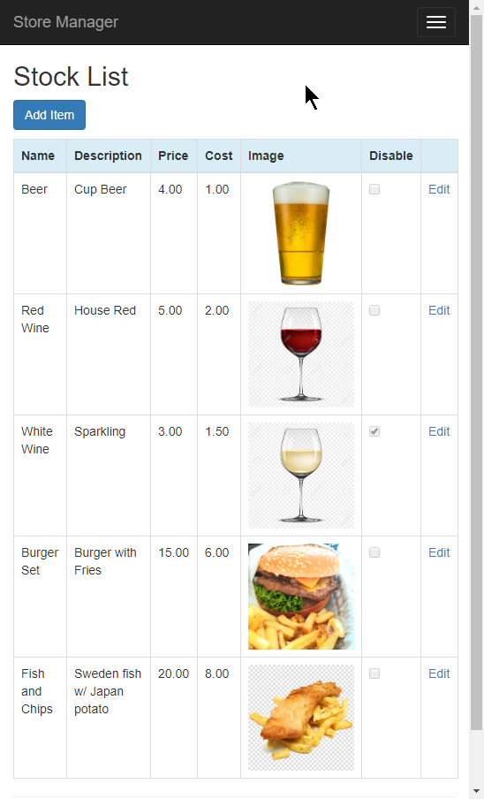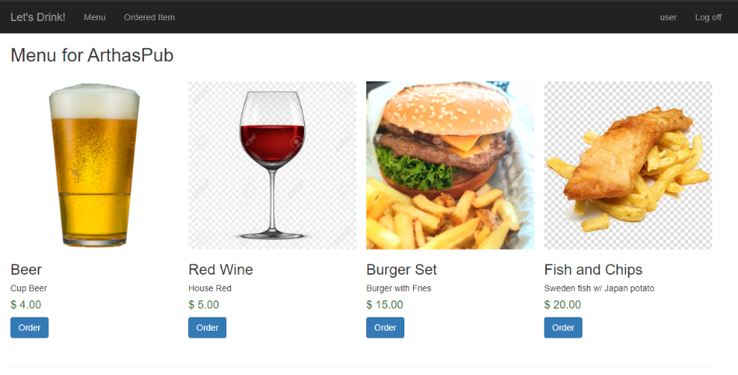

**ISAD251 Assignment Fact Sheet**

Built by Microsoft .NET ASP, can be host on all one, no extra SQL license cost.

An user friendly, and prodcutive Web Application fits every Pub establish in UK.

An user friendly, and prodcutive Web Application fits every Pub estab lish in UK

RESFUL API ready (with Help Page), Allow your bussiness partner know about your information with a single http request.

FAST ORDERING

Place order within 10 second. Click Order then Confirm!

INTEGRATED AUTHENTICATION AND AUTHORIZATION

Registration & Login the application with Role-based access control.

ADMIN SALE REPORT

One page to view all profit from every bill.

EASY TO ADD & MODIFY ITEM

Single page to update or add the item for your Pub bussiness.

MOBILE FRIENDLY DESIGN

With QR code user can access with their phone swift and simple